01_SIEM_Introduction

1. What is SIEM?
SIEM (Security Information and Event Management) is a cybersecurity solution that collects, stores, monitors and analyzes security logs from different systems to identify suspicious activities and security threats.
It helps SOC analysts detect attacks, investigate incidents and respond to security alerts.

Components of SIEM
- Log Collection: Collects logs from Windows, Linux, firewalls, servers and applications.
- Log Aggregation: Combines logs from different sources into one central location.
- Log Parsing: Converts raw logs into structured and readable information.
- Correlation Engine: Connects related events to identify suspicious patterns.
- Alert Generation: Generates alerts when suspicious activities are detected.
- Dashboard and Reporting: Displays security events, alerts and reports.
- Incident Investigation: Helps security analysts investigate and respond to threats.

SIEM Architecture and Data Flow

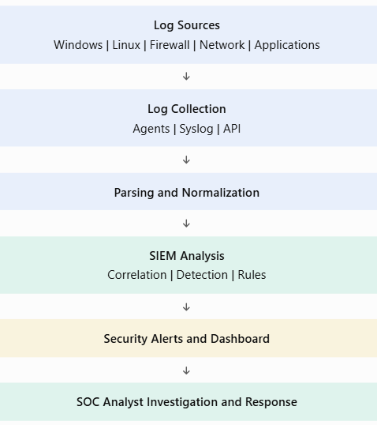

SIEM vs Log Management vs SOAR vs EDR

Feature | SIEM | Log Management | SOAR | EDR
Full form | Security Information and Event Management | Log Management | Security Orchestration, Automation and Response | Endpoint Detection and Response
Main purpose | Detect threats | Store and manage logs | Automate security responses | Monitor endpoints
Function | Analyze and correlate events | Collect and store logs | Automate workflows | Detect endpoint attacks
Example | Splunk, Wazuh | Graylog | Cortex XSOAR | Microsoft Defender for Endpoint

Advantages of SIEM
- Centralized security monitoring.
- Early threat detection.
- Real-time security alerts.
- Helps investigate incidents.
- Supports compliance and auditing.
- Improves SOC operations.

Example
If an attacker tries to log in to a Windows server 20 times using incorrect passwords, SIEM can collect the failed login events, identify the repeated attempts and generate a brute-force alert.
Conclusion: SIEM helps organizations monitor security events centrally and detect suspicious activities before they cause major damage.

